Student Name: __________________
Class and Section __________________
Total Points (15 pts) __________________
Due: August 31, 2016 before the class

Project: The Circle2D Class

CSCI 1302 Advanced Programming Principles
Armstrong Atlantic State University

Problem Description:
Define the Circle2D class that contains:
- Two double data fields named x and y that specify the center of the circle with get methods.
- A data field radius with a get method.
- A no-arg constructor that creates a default circle with (0, 0) for (x, y) and 1 for radius.
- A constructor that creates a circle with the specified x, y, and radius.
- A method getArea() that returns the area of the circle.
- A method getPerimeter() that returns the perimeter of the circle.
- A method contains(double x, double y) that returns true if the specified point (x, y) is inside this circle. See Figure 10.14(a).
- A method contains(Circle2D circle) that returns true if the specified circle is inside this circle. See Figure 10.14(b).
- A method overlaps(Circle2D circle) that returns true if the specified circle overlaps with this circle. See the figure below.

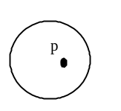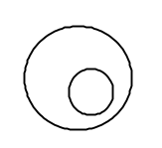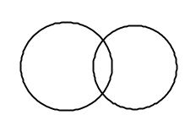

(a) (b) (c)

Figure
(a) A point is inside the circle. (b) A circle is inside another circle. (c) A circle overlaps another circle.

Draw the UML diagram for the class. Implement the class. Write a test program that creates a Circle2D object c1 (new Circle2D(2, 2, 5.5)), displays its area and perimeter, and displays the result of c1.contains(3, 3), c1.contains(new Circle2D(4, 5, 10.5)), and c1.overlaps(new Circle2D(3, 5, 2.3)).

Design:
Draw the UML class diagram here

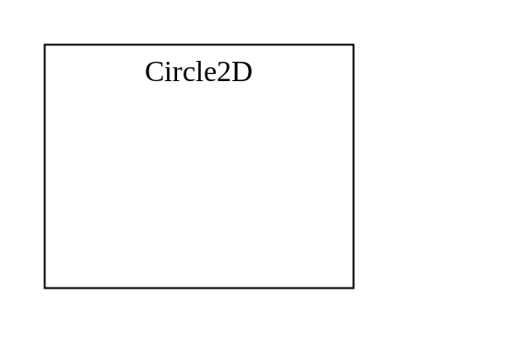

Coding: (Copy and Paste Source Code here. Format your code using Courier 10pts)

public class Exercise10_11 {
public static void main(String[] args) {
Circle2D c1 = new Circle2D(2, 2, 5.5);
System.out.println("Area is " + c1.getArea());
System.out.println("Perimeter is " + c1.getPerimeter());
System.out.println(c1.contains(3, 3));
System.out.println(c1.contains(new Circle2D(4, 5, 10.5)));
System.out.println(c1.overlaps(new Circle2D(3, 5, 2.3)));
}
}

class Circle2D {
// Implement your class here
}

Submit the following items:

1. Print this Word file and Submit to me before the class on the due day.

2. Compile, Run, and Submit to LiveLab (you must submit the program regardless whether it complete or incomplete, correct or incorrect)

Solution Code:

public class Exercise10_11 {
public static void main(String[] args) {
Circle2D c1 = new Circle2D(2, 2, 5.5);
System.out.println("Area is " + c1.getArea());
System.out.println("Perimeter is " + c1.getPerimeter());
System.out.println(c1.contains(3, 3));
System.out.println(c1.contains(new Circle2D(4, 5, 10.5)));
System.out.println(c1.overlaps(new Circle2D(3, 5, 2.3)));
}
}

class Circle2D {
private double x, y;
private double radius;

public Circle2D() {
x = 0;
y = 0;
radius = 1;
}

public Circle2D(double x, double y, double radius) {
this.x = x;
this.y = y;
this.radius = radius;
}

public double getX() {
return x;
}

public void setX(double x) {
this.x = x;
}

public double getY() {
return y;
}

public void setY(double y) {
this.y = y;
}

public double getRadius() {
return radius;
}

public void setRadius(double radius) {
this.radius = radius;
}

public double getPerimeter() {
return 2 * radius * Math.PI;
}

public double getArea() {
return radius * radius * Math.PI;
}

public boolean contains(double x, double y) {
// MyPoint is defined in Exercise9_4
double d = distance(x, y, this.x, this.y) ;
return d <= radius;
}

public boolean contains(Circle2D circle) {
return contains(circle.x - circle.radius, circle.y) &&
contains(circle.x + circle.radius, circle.y) &&
contains(circle.x, circle.y - circle.radius) &&
contains(circle.x, circle.y + circle.radius);
}

public boolean overlaps(Circle2D circle) {
// Two circles overlap if the distance between the two centers
// are less than or equal to this.radius + circle.radius
// MyPoint is defined in Exercise9_4
return distance(this.x, this.y, circle.x, circle.y)
<= radius + circle.radius;
}

private static double distance(double x1, double y1,
double x2, double y2) {
return Math.sqrt((x1 - x2) * (x1 - x2) + (y1 - y2) * (y1 - y2));
}
}

